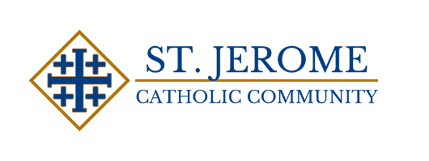

St . Jerome Catholic Church Sponsorship For m

Dear Prospective Sponsor,
Thank you for taking the �me to consider sponsoring St. Jerome Catholic Church Fall Festival. St. Jerome’s mission is to use the talents, time and treasure God has given us, in a spirit of generosity and compassion, for the good for those less fortunate than ourselves, to spread the word of God through evangelization and Catholic education, and to live our faith so that others may say, “We can tell they are Christians by their love.”
We invite you to support St. Jerome through advertising your business. If interested in this opportunity, please ﬁll out the form below. You will ﬁnd that your business will beneﬁt greatly.
Thank you for your consideration,
Jorge Garcia, Fall Festival Chairman Esther Martinez – Sponsorship Co Chair
****************************************************************************** Your business will benefit of the following:
Gold Sponsorships: Donations $1000 and above
- Company name is displayed on banner.
- Company name will be posted on our weekly bulletin and will be highlighted with info.
- Company name and brief summary of company description displayed on our website.
- Company name listed on our social media platform – (Facebook, Instagram)
Silver Sponsorships: Donations $400-$999
- Company name is displayed on banner.
- Company name displayed in weekly bulletin.
- Company name listed on social media platform.
Bronze & Other Sponsorships: Donations $50-$399
- Company name displayed on banner & weekly bulletin.
******************************************************************************
Business name and information:
If you have a logo, please email it to ehdz0222@gmail.com
Name:
Cell Phone number:
Type of business:

For Oﬃce Use only
Payment Amount: Cash Check#
Payment received by: Date Received:

